Home Page

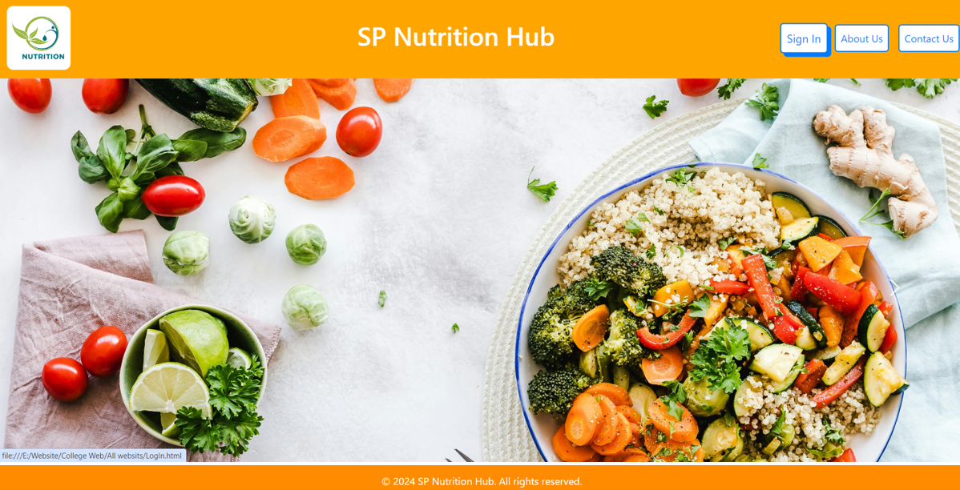

<!DOCTYPE html>

<html lang="en">

<head>

   <meta charset="UTF-8">

    <meta name="viewport" content="width=device-width, initial-scale=1.0">

    <title>Home - SP Nutrition Hub</title>

    <link rel="stylesheet" href="bootstrap.min.css">

    <link rel="stylesheet" href="yt_style.css">

   </head>

<body>

    <nav class="navbar navbar-expand-lg navbar-light">

        <div class="container-fluid">

            <a class="navbar-brand" href="#">

                <img src="Nutrition_logo.jpg">

                <h1>SP Nutrition Hub</h1>

            </a>

            <button class="navbar-toggler" type="button" data-bs-toggle="collapse" data-bs-target="#navbarNav" aria-controls="navbarNav" aria-expanded="false" aria-label="Toggle navigation">

                <span class="navbar-toggler-icon"></span>

            </button>

            <div class="collapse navbar-collapse justify-content-end" id="navbarNav">

                <ul class="navbar-nav">

                    <li class="nav-item">

                        <a class="nav-link" href="LogIn.html">Sign In</a>

                    </li>

                    <li class="nav-item">

                        <a class="nav-link" href="About Us.html">About Us</a>

                    </li>

                    <li class="nav-item">

                        <a class="nav-link" href="Contact Us.html">Contact Us</a>

                    </li>

                </ul>

            </div>

        </div>

    </nav>

    <div id="nutritionCarousel" class="carousel slide" data-bs-ride="carousel" data-bs-interval="3000">

        <div class="carousel-inner">

            <div class="carousel-item active" style="background-image: url('n.jpg');">

            </div>

            <div class="carousel-item" style="background-image: url('img.png');">

            </div>

            <div class="carousel-item" style="background-image: url('ve.jpg');">

            </div>

            <div class="carousel-item" style="background-image: url('Fr_Ve.jpg');">

            </div>

        </div>

        <button class="carousel-control-prev" type="button" data-bs-target="#nutritionCarousel" data-bs-slide="prev">

            <span class="carousel-control-prev-icon" aria-hidden="true"></span>

            <span class="visually-hidden">Previous</span>

        </button>

        <button class="carousel-control-next" type="button" data-bs-target="#nutritionCarousel" data-bs-slide="next">

            <span class="carousel-control-next-icon" aria-hidden="true"></span>

            <span class="visually-hidden">Next</span>

        </button>

    </div>

    <footer>

        &copy; 2024 SP Nutrition Hub. All rights reserved.

    </footer>

    <script src="https://cdn.jsdelivr.net/npm/bootstrap@5.3.0/dist/js/bootstrap.bundle.min.js"></script>

</body>

</html>

Home Page Css

.navbar {

    background-color: orange;

}

.navbar-brand img {

    width: 100px;

    height: 100px;

    margin-right: 10px;

    border-radius: 10px;

}

.navbar-brand {

    display: flex;

    align-items: center;

}

h1{

    color: white;

    margin-left: 440px;

}

.navbar-nav .nav-link {

    color: #007BFF;

    font-size: 16px;

    padding: 8px 15px;

    margin-left: 15px;

    background-color: white;

    border-radius: 5px;

    border: 2px solid #007BFF;

}

.nav-link:hover {

    transform: scale(1.1);

    transition: transform 0.3s ease;

    box-shadow: 5px 5px 0px;

}

.carousel-item {

    height: 90vh;

    background-size: cover;

    background-position: center;

}

footer {

    background-color: #FF8C00;

    color: white;

    text-align: center;

    padding: 15px 0;

}

SignIn Page

LogIn Page

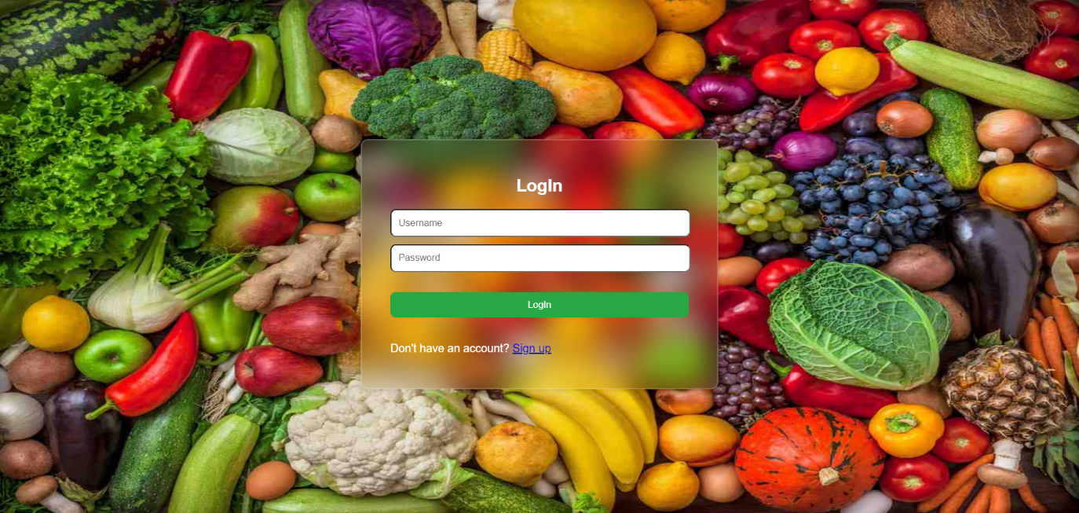

<!DOCTYPE html>

<html lang="en">

<head>

    <meta charset="UTF-8">

    <meta name="viewport" content="width=device-width, initial-scale=1.0">

    <title>LogIn</title>

    <link rel="stylesheet" href="LogIn.css">

</head>

<body background="image jpg.jpg">

    <div class="login-container">

    <center><h2>LogIn</h2></center>

    <script>

        function data()

        {

            var a=document.getElementById("n1").value;

            var b=document.getElementById("n2").value;

            if(a==""||b=="")

            {

                alert("All Fields are Mendatory.");

                return false;

            }

            else if(b!=1234)

            {

                alert("Wrong Password!");

                return false;

            }

            else

            {

                true;

            }

        }

    </script>

    <form action="Home.html" onsubmit="return data();">

        <input type="text" placeholder="Username" id="n1">

        <input type="password" placeholder="Password" id="n2"><br><br>

        <button class="login">LogIn</button><br>

        <br><p>Don't have an account? <a href="Register.html">Sign up</a></p>

    </form>

</body>

</html>

Login Page Css

/* login.HTML */

body { font-family: Arial, sans-serif; background-color: #f4f4f4; display: flex; justify-content: center; align-items: center; height: 100vh;background-image: url(Fr_Ve.jpg);background-repeat: no-repeat;background-attachment: fixed;background-size: 100% 100%;}

input { margin-bottom: 10px; padding: 10px; width: 95%;border-radius: 8px;}

button { padding: 10px; width: 100%; background-color: #28a745; color: white; border: none; border-radius: 8px; border: 20px;}

.login-container {

        width: 420px;

        background: transparent;

        border: 2px solid rgba(255, 255, 255, .2);

        backdrop-filter: blur(20px);

        box-shadow: 0 0 10px rgba(0, 0, 0,.2);

        color: rgb(255, 255, 255);

        border-radius: 10px;

        padding: 30px 40px;

}

.login:hover {

transform: scale(1.1);

background-color: blue;

box-shadow: 5px 5px 0px black;

}

SignIn Page

Register Page

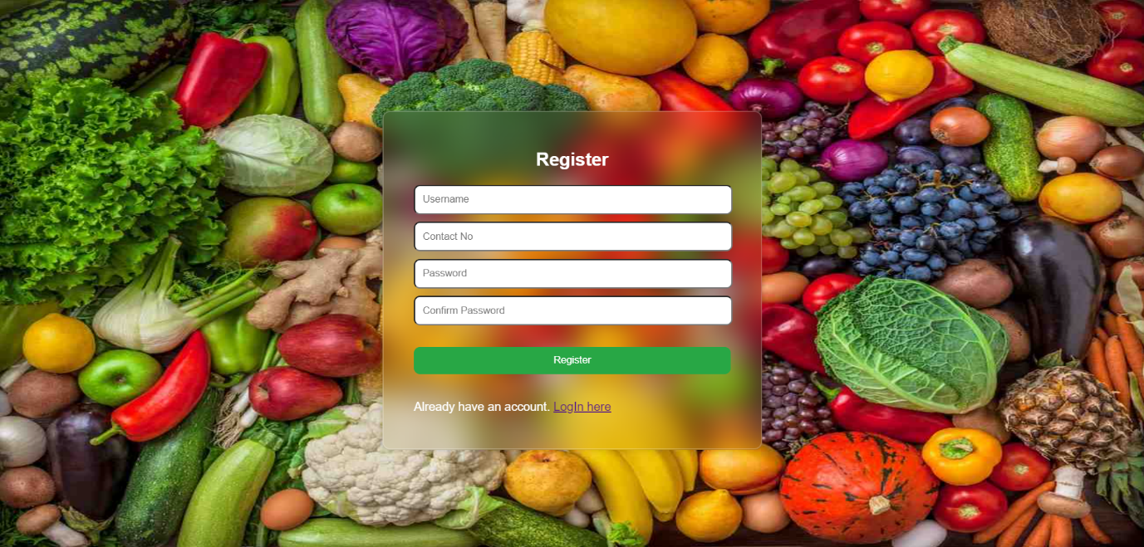

<!DOCTYPE html>

<html lang="en">

<head>

    <meta charset="UTF-8">

    <meta name="viewport" content="width=device-width, initial-scale=1.0">

    <title>Register</title>

    <link rel="stylesheet" href="Register.css">

</head>

<body background="image jpg.jpg">

    <div class="login-container">

    <center><h2>Register</h2></center>

    <script>

        function data()

        {

            var a=document.getElementById("n1").value;

            var b=document.getElementById("n2").value;

            var c=document.getElementById("n3").value;

            var d=document.getElementById("n4").value;

            if(a==""||b==""||c==""||d=="")

            {

                alert("All Fields are Mendatory.");

                return false;

            }

            else if(b.length<10||b.length>10)

            {

                alert("Number should be of 10 Digits! Please enter valid Numbers.");

                return false;

            }

            else if(isNaN(b))

            {

                alert("Only Number are allowed! Please enter valid Numbers.");

                return false;

            }

            else if(c!=d)

            {

                alert("Please enter same Password");

                return false;

            }

            else

            {

                true;

            }

        }

    </script>

    <form action="Home.html" onsubmit="return data();">

        <input type="text" placeholder="Username" id="n1">

        <input type="text" placeholder="Contact No" id="n2">

        <input type="password" placeholder="Password" id="n3">

        <input type="password" placeholder="Confirm Password" id="n4"><br><br>

        <button class="register">Register</button><br>

        <br><p>Already have an account. <a href="LogIn.html">LogIn here</a></p>

    </form>

</body>

</html>

Register Page Css

/* Register.HTML */

body { font-family: Arial, sans-serif; background-color: #f4f4f4; display: flex; justify-content: center; align-items: center; height: 100vh;background-image: url(Fr_Ve.jpg);background-repeat: no-repeat;background-attachment: fixed;background-size: 100% 100%;}

input { margin-bottom: 10px; padding: 10px; width: 95%;border-radius: 8px;}

button { padding: 10px; width: 100%; background-color: #28a745; color: white; border: none; border-radius: 8px; border: 20px;}

.login-container {

        width: 420px;

        background: transparent;

        border: 2px solid rgba(255, 255, 255, .2);

        backdrop-filter: blur(20px);

        box-shadow: 0 0 10px rgba(0, 0, 0,.2);

        color: rgb(255, 255, 255);

        border-radius: 10px;

        padding: 30px 40px;

}

.register:hover {

    transform: scale(1.1);

    background-color: blue;

    box-shadow: 5px 5px 0px black;

}

Introduction page

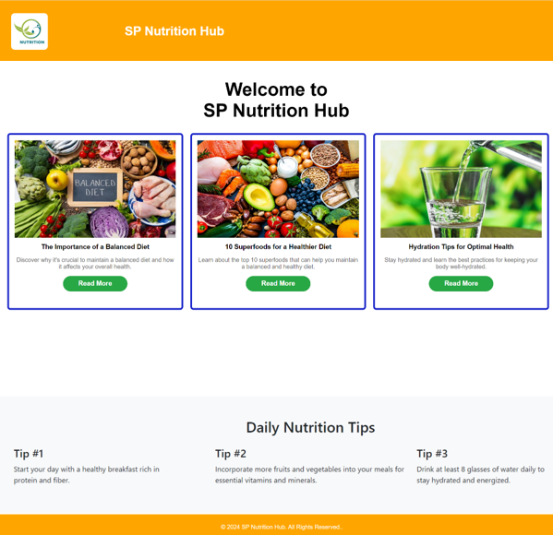

<!DOCTYPE html>

<html lang="en">

<head>

    <meta charset="UTF-8">

    <meta name="viewport" content="width=device-width, initial-scale=1.0">

    <title>Home</title>

    <link rel="stylesheet" href="Home.css">

     <link rel="stylesheet" href="bootstrap.min.css">

</head>

<body>

    <div class="navbar">

        <div class="logo">

            <a class="navbar-brand" href="#">

                <img src="Nutrition_logo.jpg">

                <h1 style="padding-left: 53%;">SP Nutrition Hub</h1>

            </a>

        </div>

        <div class="search" style="margin-left: 900px;">

        </div>

    </div>

    <div class="content">

        <div class="section">

            <center><h1>Welcome to <br> SP Nutrition Hub</h1>

                <div class="products">

                    <div class="product">

                        <img  src="image2.jpg" alt="Jewelry 1" height="80%" width="250%">

                        <h3>The Importance of a Balanced Diet</h3>

                        <p>Discover why it's crucial to maintain a balanced diet and how it affects your overall health.</p>

                        <form action="Home_page_BD.html" name="form1">

                            <button style="background-color: #28a745; border: #694f10; border-radius: 50px; width: 40%; height: 15%; color: #fff;"><h3>Read More</h3></button>

                        </form>

                    </div>

                <div class="product">

                    <img  src="image.jpg" alt="Jewelry 1" height="80%" width="250%">

                    <h3>10 Superfoods for a Healthier Diet</h3>

                    <p>Learn about the top 10 superfoods that can help you maintain a balanced and healthy diet.</p>

                    <form action="Home_page_10.html" name="form1">

                        <button style="background-color: #28a745; border: #ffb300; border-radius: 50px; width: 40%; height: 15%; color: #fff;"><h3>Read More</h3></button>

                    </form>

                </div>

                <div class="product">

                    <img  src="image3.jpg" alt="Jewelry 1" height="80%" width="250%">

                    <h3>Hydration Tips for Optimal Health</h3>

                    <p>Stay hydrated and learn the best practices for keeping your body well-hydrated.</p>

                    <form action="Home_page_3.html" name="form1">

                        <button style="background-color: #28a745; border: #ffb300; border-radius: 50px; width: 40%; height: 15%; color: #fff;"><h3>Read More</h3></button>

                    </form>

                </div>

            </div>

        </div>

    </div>

<br><br><br>

    <section class="bg-light py-5">

        <div class="container">

            <h2 class="text-center">Daily Nutrition Tips</h2>

            <div class="row mt-4">

                <div class="col-md-4">

                    <div class="tip-box">

                        <h4>Tip #1</h4>

                        <p>Start your day with a healthy breakfast rich in <br> protein and fiber.</p>

                    </div>

                </div>

                <div class="col-md-4">

                    <div class="tip-box">

                        <h4>Tip #2</h4>

                        <p>Incorporate more fruits and vegetables into your meals for <br> essential vitamins and minerals.</p>

                    </div>

                </div>

                <div class="col-md-4">

                    <div class="tip-box">

                        <h4>Tip #3</h4>

                        <p>Drink at least 8 glasses of water daily to <br>stay hydrated and energized.</p>

                    </div>

                </div>

            </div>

        </div>

    </section>

    <div class="footer">

        <p>&copy; 2024 SP Nutrition Hub. All Rights Reserved..</p>

    </div>

</body>

</html>

Introduction page Css

.navbar {

    background-color:orange;

    width: 100%;

    height: 150px;

    padding: 10px 15px;

    display: flex;

    justify-content:left;

    align-items: center;

}

.navbar a {

    color: #fff;

    text-decoration:none;

    padding: 0 15px;

    font-size: 14px;

    font-weight: bold;

}

.navbar-brand img {

width: 100px;

height: 100px;

margin-right: 10px;

border-radius: 10px;

}

.navbar-brand {

display: flex;

align-items: center;

}

h1{

color: white;

margin-left: 440px;

font-size: 50px;

}

.navbar-brand h1{

    font-size: 34px;

    margin-inline-start: 200px;

    color: white;

}

.content {

    margin-top: 0px;

    padding: 20px;

}

.section h1 {

    color: black;

    margin-right: 450px;

}

.products {

    display: flex;

    flex-wrap: wrap;

    gap: 20px;

}

.product {

    flex: 1 1 calc(33.333% - 20px);

    box-sizing: border-box;

    background-color: #fff;

    border: 5px solid #1d28ca;

    border-radius: 8px;

    overflow: hidden;

    padding: 15px;

    text-align: center;

    animation: fadeInDown 2s ease;

}

.product img {

    max-width: 100%;

    height: 60%;

    border-bottom: 1px solid #ddd;

}

.product h3 {

    font-size: 18px;

    margin: 10px 0;

}

.product p {

    color: #666;

}

.footer {

    background-color: orange;

    color: #fff;

    text-align: center;

    padding: 10px;

    position: relative;

    bottom: 0;

    width: 100%;

}

Read More Page-1

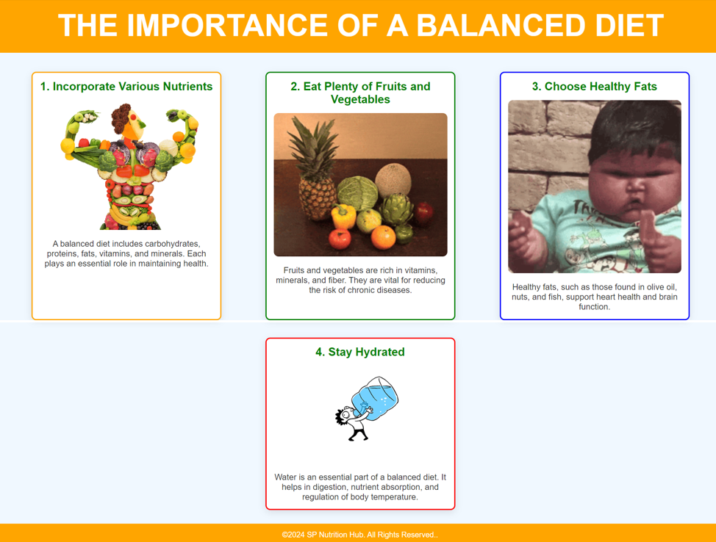

<!DOCTYPE html>

<html lang="en">

<head>

    <meta charset="UTF-8">

    <meta name="viewport" content="width=device-width, initial-scale=1.0">

    <title>The Importance of a Balanced Diet</title>

    <link rel="stylesheet" href="Home_page_BD.css">

</head>

<body>

    <header>

        <h1>The Importance of a Balanced Diet</h1>

    </header>

    <section class="content">

        <article class="point" id="point1">

            <h2>1. Incorporate Various Nutrients</h2>

            <img src="I_V_N.gif" alt="Incorporate Various Nutrients">

            <p>A balanced diet includes carbohydrates, proteins, fats, vitamins, and minerals. Each plays an essential role in maintaining health.</p>

        </article>

        <article class="point" id="point2">

            <h2>2. Eat Plenty of Fruits and Vegetables</h2>

            <img src="Eat Plenty of Fruits and Vegetables.gif" alt="Fruits and Vegetables">

            <p>Fruits and vegetables are rich in vitamins, minerals, and fiber. They are vital for reducing the risk of chronic diseases.</p>

        </article>

        <article class="point" id="point3">

            <h2>3. Choose Healthy Fats</h2>

            <img src="Choose Healthy Fats.gif">

            <p>Healthy fats, such as those found in olive oil, nuts, and fish, support heart health and brain function.</p>

        </article>

        <article class="point" id="point4">

            <h2>4. Stay Hydrated</h2>

            <img src="Stay Hydrated.gif">

            <p>Water is an essential part of a balanced diet. It helps in digestion, nutrient absorption, and regulation of body temperature.</p>

        </article>

    </section>

<br><br>

    <footer>

        <p>&copy;2024 SP Nutrition Hub. All Rights Reserved..</p>

    </footer>

</body>

</html>

Read More Page-1 Css

* {

    margin: 0;

    padding: 0;

    box-sizing: border-box;

}

body {

    font-family: 'Arial', sans-serif;

    background-color: #f0f8ff;

}

header {

    background-color: orange;

    text-align: center;

    padding: 20px;

    color: white;

    font-size: 2rem;

    text-transform: uppercase;

    animation: headerAnimation 2s ease-out;

}

.content {

    display: flex;

    flex-wrap: wrap;

    justify-content: space-around;

    padding: 20px;

}

.point {

    background-color: white;

    width: 400px;

    margin: 20px;

    padding: 15px;

    border-radius: 10px;

    box-shadow: 0 5px 15px rgba(0, 0, 0, 0.1);

    text-align: center;

    animation: pointSlideUp 1s ease-out;

}

.point h2 {

    color: green;

    margin-bottom: 15px;

}

.point img {

    width: 100%;

    height: auto;

    border-radius: 10px;

    margin-bottom: 15px;

}

.point p {

    font-size: 1.1rem;

    color: #333;

}

footer {

    background-color: orange;

    color: white;

    text-align: center;

    padding: 15px 0;

    position: fixed;

    width: 100%;

    bottom: 0;

}

@keyframes headerAnimation {

    0% {

        opacity: 0;

        transform: translateY(-50px);

    }

    100% {

        opacity: 1;

        transform: translateY(0);

    }

}

@keyframes pointSlideUp {

    0% {

        opacity: 0;

        transform: translateY(50px);

    }

    100% {

        opacity: 1;

        transform: translateY(0);

    }

}

#point1 {

    border: 3px solid orange;

}

#point2 {

    border: 3px solid green;

}

#point3 {

    border: 3px solid blue;

}

#point4 {

    border: 3px solid red;

}

Read More Page-2

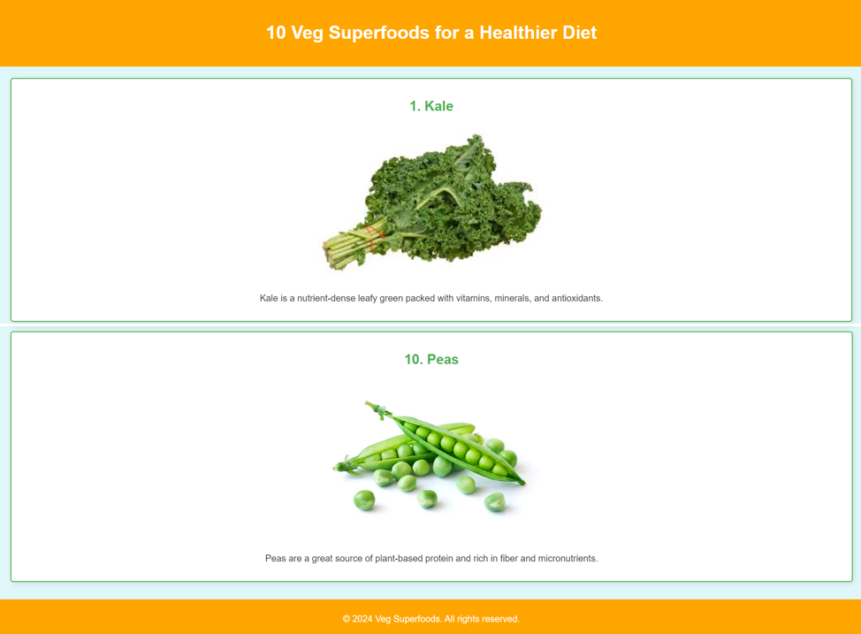

<!DOCTYPE html>

<html lang="en">

<head>

    <meta charset="UTF-8">

    <meta name="viewport" content="width=device-width, initial-scale=1.0">

    <title>10 Veg Superfoods for a Healthier Diet</title>

    <link rel="stylesheet" href="Home_page_10.css">

</head>

<body>

    <header>

        <h1>10 Veg Superfoods for a Healthier Diet</h1>

    </header>

    <section class="superfoods">

        <article class="food-item">

            <h2>1. Kale</h2>

            <img src="kale.jpg" alt="Kale">

            <p>Kale is a nutrient-dense leafy green packed with vitamins, minerals, and antioxidants.</p>

        </article>

        <article class="food-item">

            <h2>2. Spinach</h2>

            <img src="spinach.jpg" alt="Spinach">

            <p>Spinach is a great source of iron, calcium, and magnesium, making it excellent for bone health.</p>

        </article>

        <article class="food-item">

            <h2>3. Broccoli</h2>

            <img src="broccoli.jpg" alt="Broccoli">

            <p>Broccoli is high in fiber, vitamins C and K, and known for its cancer-fighting properties.</p>

        </article>

        <article class="food-item">

            <h2>4. Carrots</h2>

            <img src="carrots.jpg" alt="Carrots">

            <p>Carrots are rich in beta-carotene, which supports eye health and boosts the immune system.</p>

        </article>

        <article class="food-item">

            <h2>5. Sweet Potatoes</h2>

            <img src="sweet-potatoes.jpg" alt="Sweet Potatoes">

            <p>Sweet potatoes are packed with fiber and vitamins, making them a fantastic addition to a healthy diet.</p>

        </article>

        <article class="food-item">

            <h2>6. Brussels Sprouts</h2>

            <img src="brussels-sprouts.jpg" alt="Brussels Sprouts">

            <p>Brussels sprouts are loaded with antioxidants and help reduce inflammation.</p>

        </article>

        <article class="food-item">

            <h2>7. Avocado</h2>

            <img src="avocado.jpg" alt="Avocado">

            <p>Avocados are full of healthy fats, fiber, and essential vitamins like E and K.</p>

        </article>

        <article class="food-item">

            <h2>8. Cauliflower</h2>

            <img src="cauliflower.jpg" alt="Cauliflower">

            <p>Cauliflower is low in calories but high in vitamins C, K, and folate, great for heart health.</p>

        </article>

        <article class="food-item">

            <h2>9. Beets</h2>

            <img src="beets.jpg" alt="Beets">

            <p>Beets are rich in nitrates, which help improve blood pressure and boost exercise performance.</p>

        </article>

        <article class="food-item">

            <h2>10. Peas</h2>

            <img src="peas.jpg" alt="Peas">

            <p>Peas are a great source of plant-based protein and rich in fiber and micronutrients.</p>

        </article>

    </section>

    <footer>

        <p>&copy; 2024 Veg Superfoods. All rights reserved.</p>

    </footer>

</body>

</html>

Read More Page-2 Css

body {

    font-family: Arial, sans-serif;

    margin: 0;

    padding: 0;

    background-color: #f4f4f4;

    color: #333;

    animation: fadeIn 1.5s ease-in;

}

@keyframes fadeIn {

    from {

        opacity: 0;

    }

    to {

        opacity: 1;

    }

}

header {

    background-color: #FFA500;

    color: white;

    text-align: center;

    padding: 20px;

    animation: slideInDown 1s ease-out;

}

@keyframes slideInDown {

    from {

        transform: translateY(-100%);

        opacity: 0;

    }

    to {

        transform: translateY(0);

        opacity: 1;

    }

}

.superfoods {

    padding: 20px;

    background-color: #E0F7FA; /* Light Blue background */

}

.food-item {

    background-color: #ffffff;

    border: 2px solid #4CAF50; /* Green border */

    padding: 15px;

    margin-bottom: 10px;

    border-radius: 5px;

    box-shadow: 2px 2px 8px rgba(0, 0, 0, 0.1);

    text-align: center;

    transition: transform 0.3s ease;

    animation: slideUp 1.2s ease-out;

}

@keyframes slideUp {

    from {

        transform: translateY(50px);

        opacity: 0;

    }

    to {

        transform: translateY(0);

        opacity: 1;

    }

}

.food-item:hover {

    transform: scale(1.05);

}

.food-item h2 {

    color: #4CAF50;

}

.food-item img {

    width: 100%;

    max-width: 400px;

    height: auto;

    border-radius: 5px;

    margin: 10px 0;

    animation: zoomIn 0.5s ease-in;

}

@keyframes zoomIn {

    from {

        transform: scale(0.8);

        opacity: 0;

    }

    to {

        transform: scale(1);

        opacity: 1;

    }

}

footer {

    background-color: #FFA500;

    color: white;

    text-align: center;

    padding: 10px 0;

    animation: fadeIn 2s ease-in;

}